RDS BACKUP
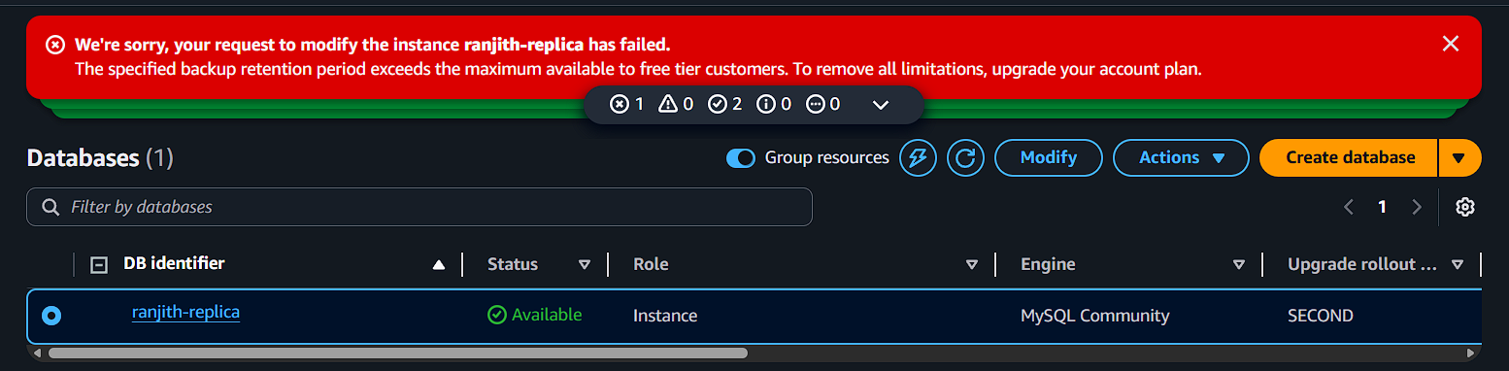

Backup not working free tier accounts……bye

